Lab 7. Testing REST

# Setup

1. Go to **File -> New -> Spring Starter Project** to create a new Spring Project
2. Type the following information in the wizard:

**Service URL:** <https://start.spring.io>

**Name:** testRest

**Group:** mx.tec.lab

**Artifact**: testRest

**Description:** Testing REST Test Lab

**Package:** mx.tec.lab

1. Select Spring Boot Version 2.4.3 and Select Spring Web Dependency and click Finish
2. Open pom.xml file and verify you have the following dependencies

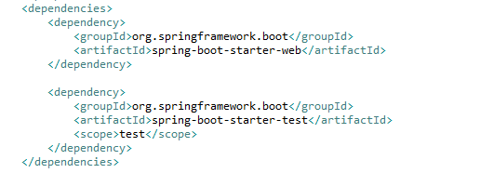

1. Verify that you have the **TestRestApplication** class in src/main/java (Package Explorer)
2. Verify that you have the **TestRestApplicationTests** class in src/test/java (Package Explorer)
3. Click on **Run As -> Maven clean**
4. Verify that clean was successful in the Console
5. Click on **Run As -> Maven install**
6. Verify that install was successful in the Console

# Exercise

1. Create new package mx.tec.lab.dto in src/main/java and create class Greeting

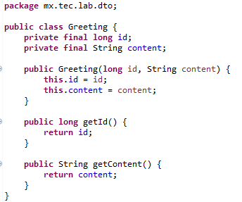

1. Create new package mx.tec.lab.rest in src/main/java and create class GreetingRestController

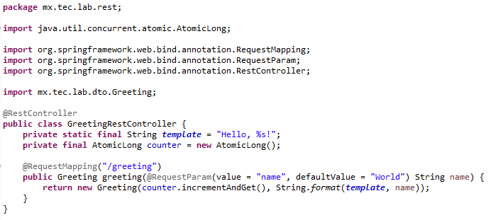

1. Run the application as **Spring Boot App**
2. Go to <http://localhost:8080/greeting> in the browser

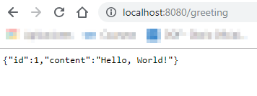

1. Go to <http://localhost:8080/greeting?name=Jon+Snow> in the browser

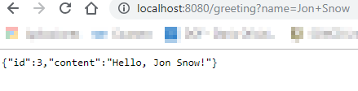

1. Stop the application

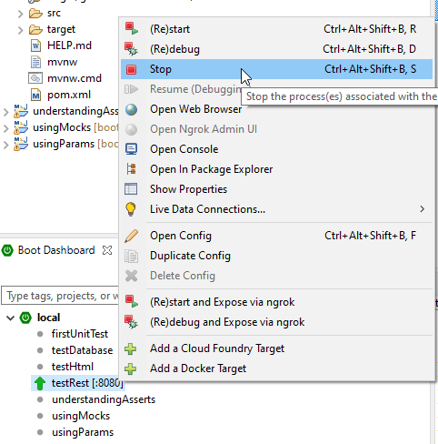

1. Delete class TestRestApplicationTests
2. Create new package mx.tec.lab.rest in src/test/java and create class GreetingRestControllerTest

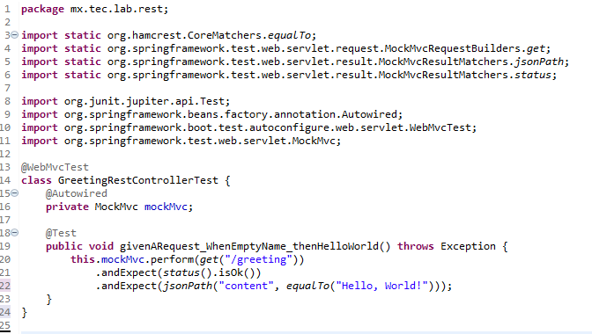

1. Run JUnit Test and see the results

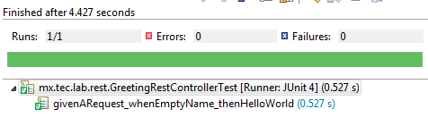

# Challenge

1. Make the method givenARequest_whenProvidedName_thenHelloName()
   * /greeting?name=Jon
2. Make the method givenARequest_whenNullName_thenHelloWorld()
   * /greeting?name=
3. Make the method givenARequest_whenWrongURL_thenError404()
   * /greting
4. Create a Goodbye method in the RestController
   * /goodbye?name=Cersei
5. Create 2 test methods for goodbye